# SQL Database – Creating a SQL Logical Server

SQL Database is a Cloud based database service built for application developers. It lets us scale on-the-fly, without downtime by efficiently delivering our applications. Built-in advisors quickly learn our application's unique characteristics and dynamically adapt to maximize the performance, reliability, and data protection.

SQL Database logical server can host databases and elastic database pools for SQL Database or host SQL Data Warehouse databases, or be used as the remote endpoint for a SQL Server stretch database.

**Prerequisites**

* Azure account.

Now, let's get started with the following steps.

**Create an Azure SQL Database logical server**

**Step 1:** Sign in to the online [Microsoft Azure Portal](https://portal.azure.com/).

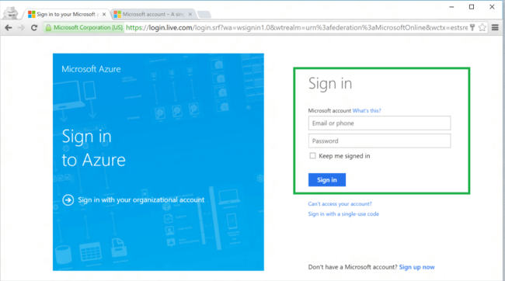

**Step 2:** Click **New**, type **SQL Database** in the Marketplace, and then click **SQL Database (logical server)**.

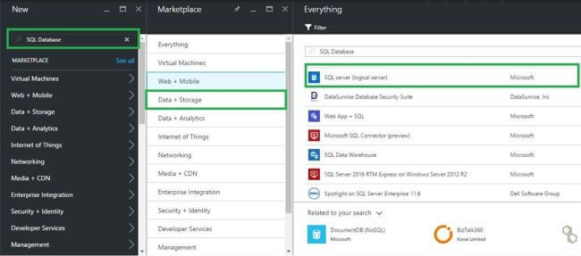

**Step 3:** Next, click **Create** to open a template for creating an empty logical server that can host single databases and elastic database pools.

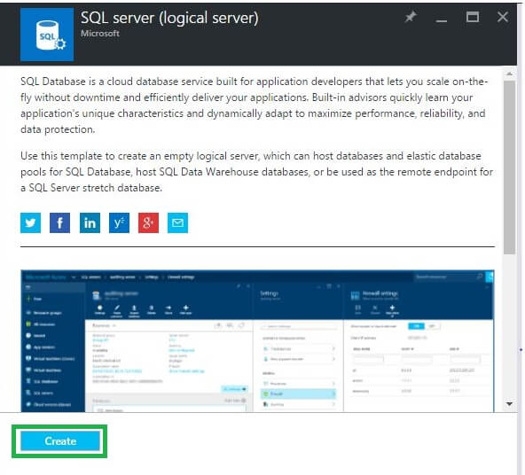  
 **Step 4:** In the New Logical Server account blade, specify the values for the following server properties: Server name, Server admin login, Password, Subscription (only if you have multiple subscriptions), Resource group (new or existing) and Location. Finally, click **Create**button.

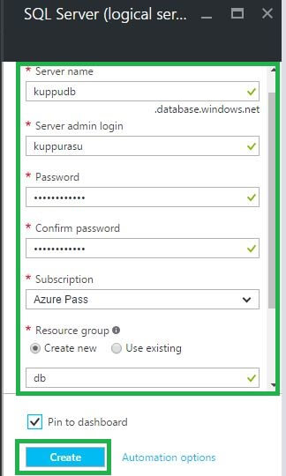  
  
In the notification area, we can see that deployment has started. Then, a few minutes later, we get **New Azure SQL Database logical server**.  
  
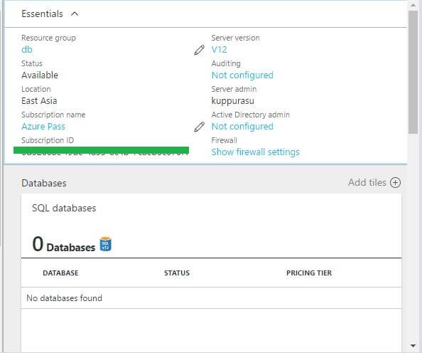

**Summary**In this article, we discussed the steps of creating an Azure SQL Database logical server, by using Azure Portal.